Manually adding Monday.com to Microsoft Authenticator
If you are a Salesforce user, or a user of another platform that use the Microsoft Authenticator, you will need to set up Microsoft Authenticator manually for Monday.com. If you use the QR code generated it will overwrite your existing code, rendering you unable to log into Salesforce or your other platform. This document will guide you on how to set it up access to avoid that. If you do not use a different platform that requires Duo Authentication this guide is not needed, and you may set up your account via the QR code.
- Navigate to your profile on Monday.com.
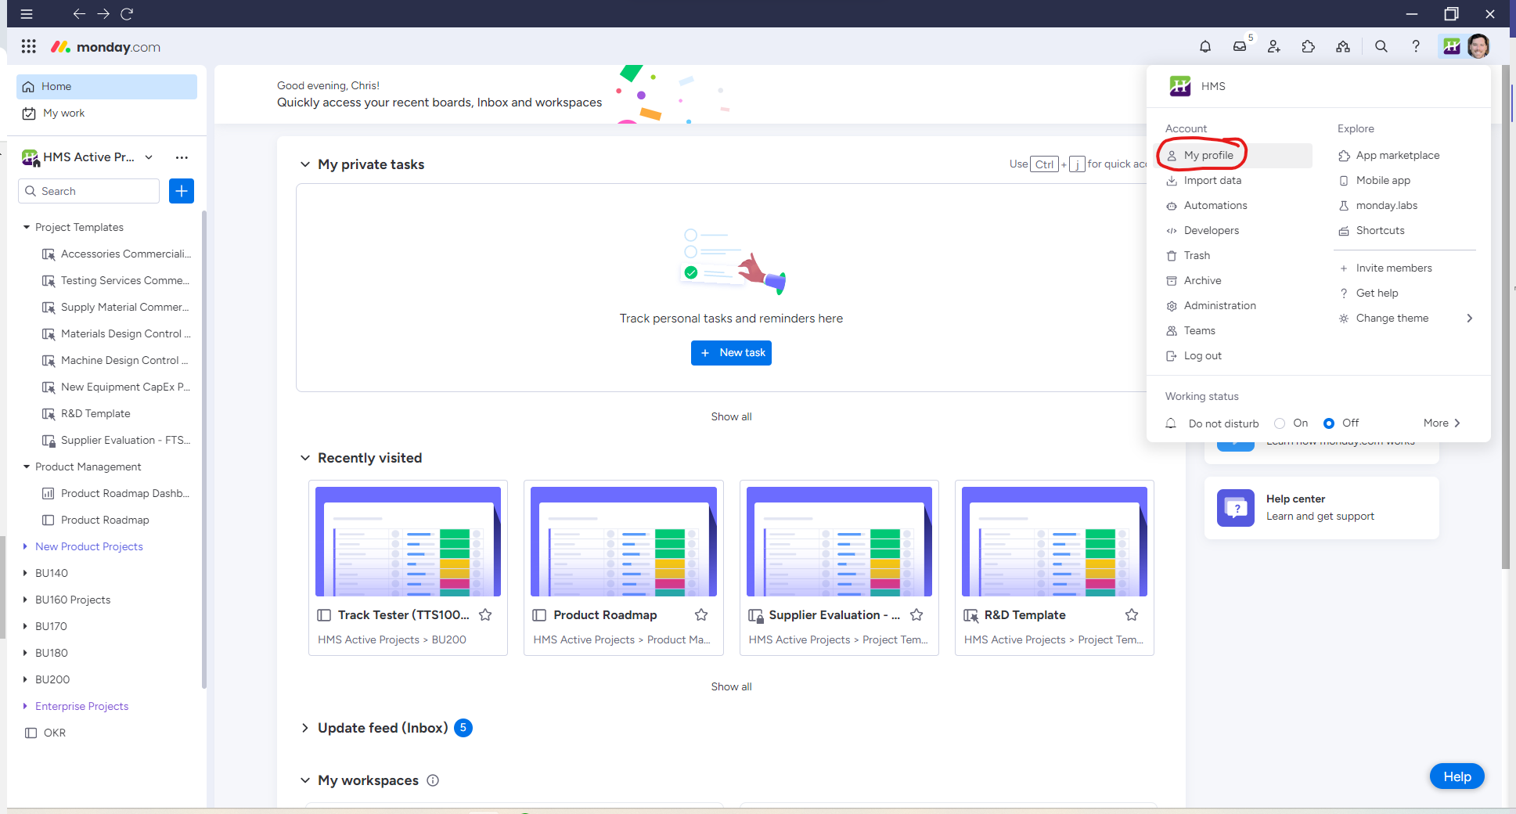
- Select the “Two-Factor Authentication” tab.
- Setup with Authentication App.
- Click “Copy Code Instead”.
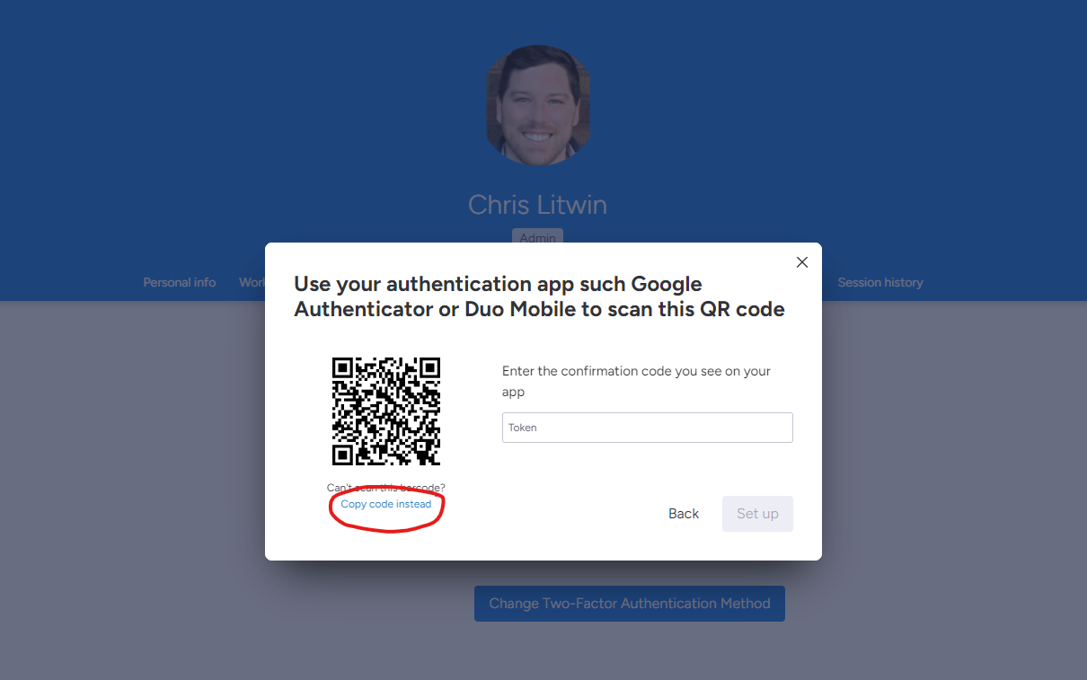
- Code will be copied to your clipboard.
- Open Microsoft Authentication App on your phone.
- Select the “plus” button to add account.
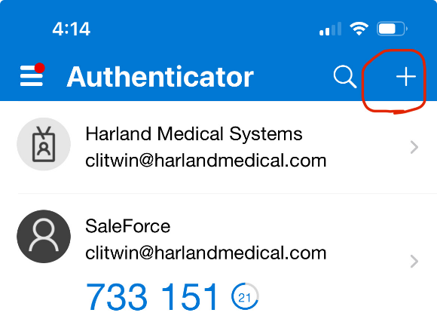
- Select “Other”.
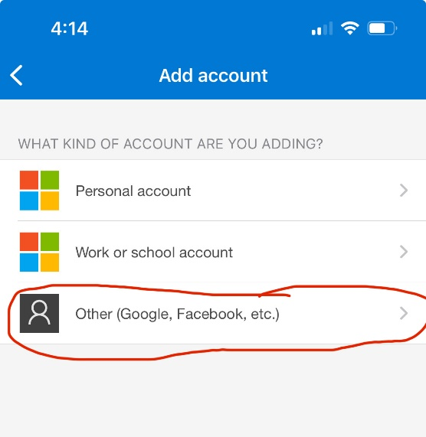
- Enter “Monday.com” as account name.
- Enter code copied on step four.
  - Tip: If you have Teams on your phone, paste the code in a Teams message to yourself on your desktop and then copy the message on your phone to avoid manual entry (the code is long!)
